Step 1
First Step is to open Revit Application above version 2017.
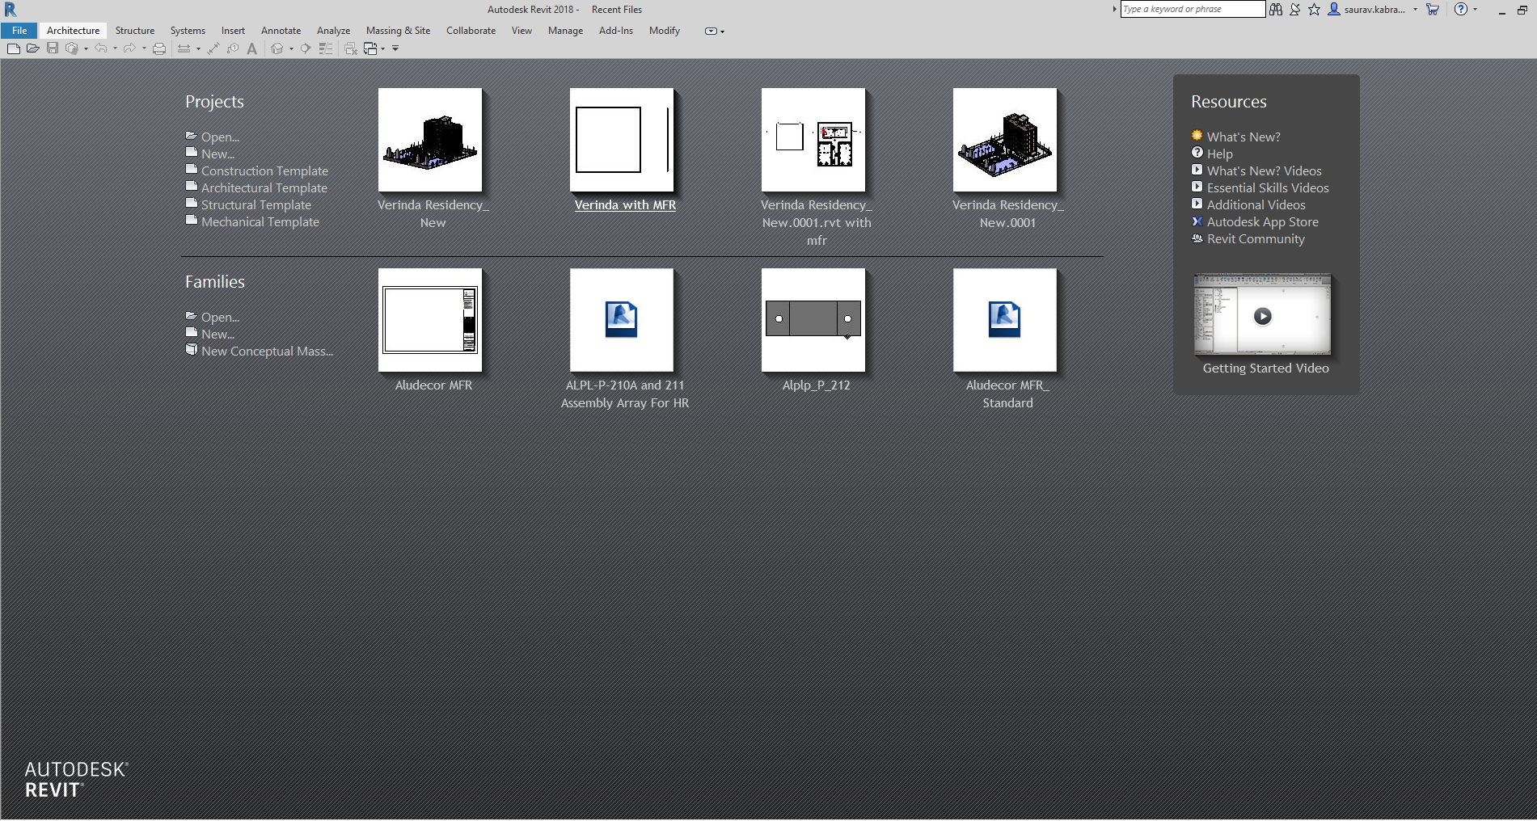
Step 2
Click on the new project and then select the path of Aludecor MFR tempate.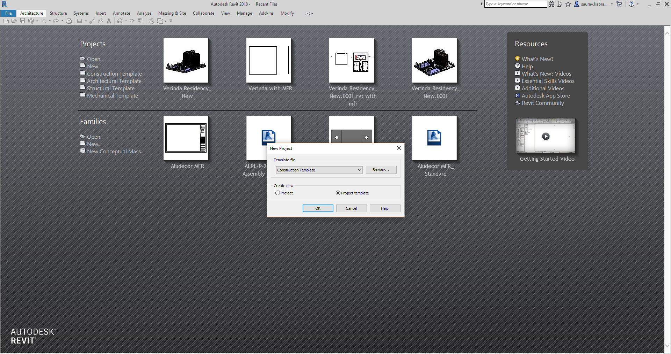
Step 3
Select the path of Aludecor MFR template and open the template.
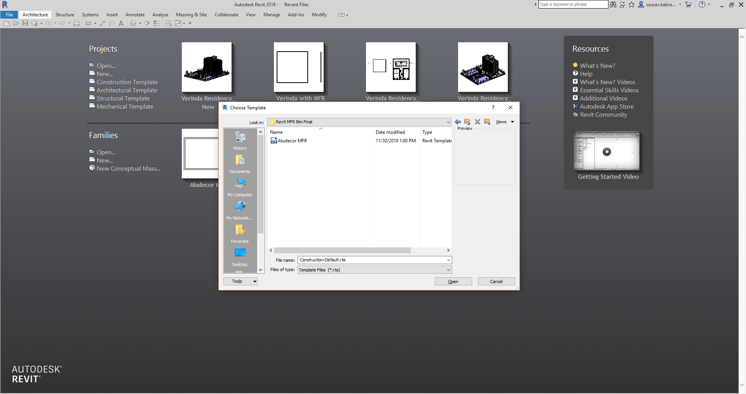
Step 4
Create the dead wall where we need to install the curtain panel system.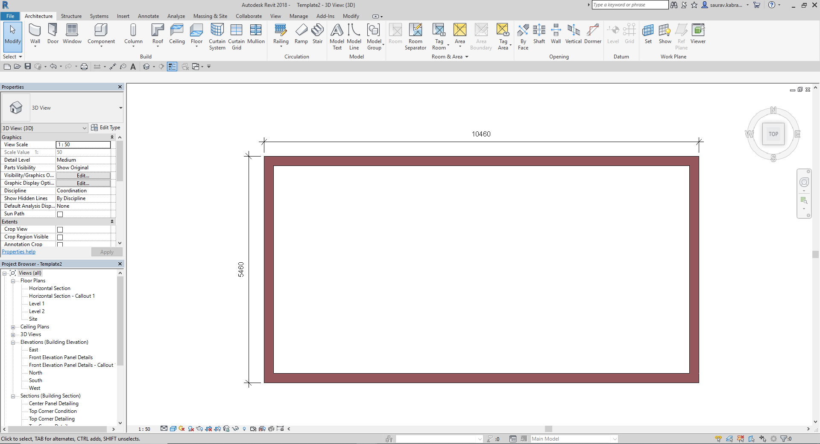

Step 5
Create the Aludecor MFR system using the Wall Button and then Select the curtain Wall and sketch the line where we need to install MFR system then select Done.

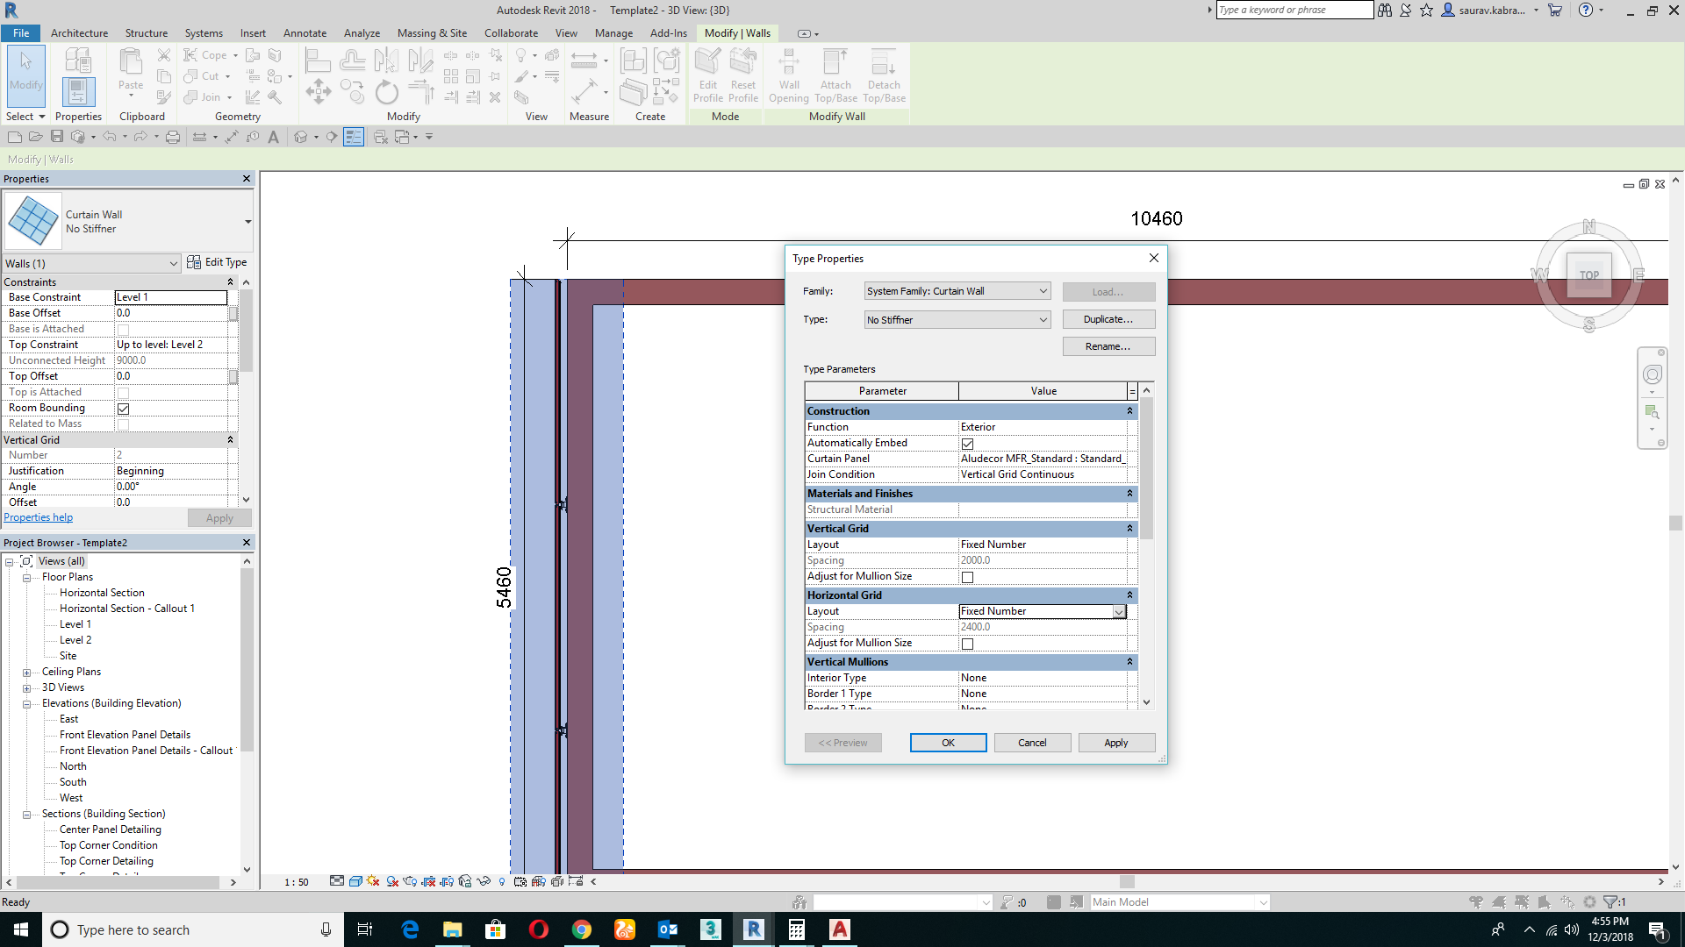
Step 6
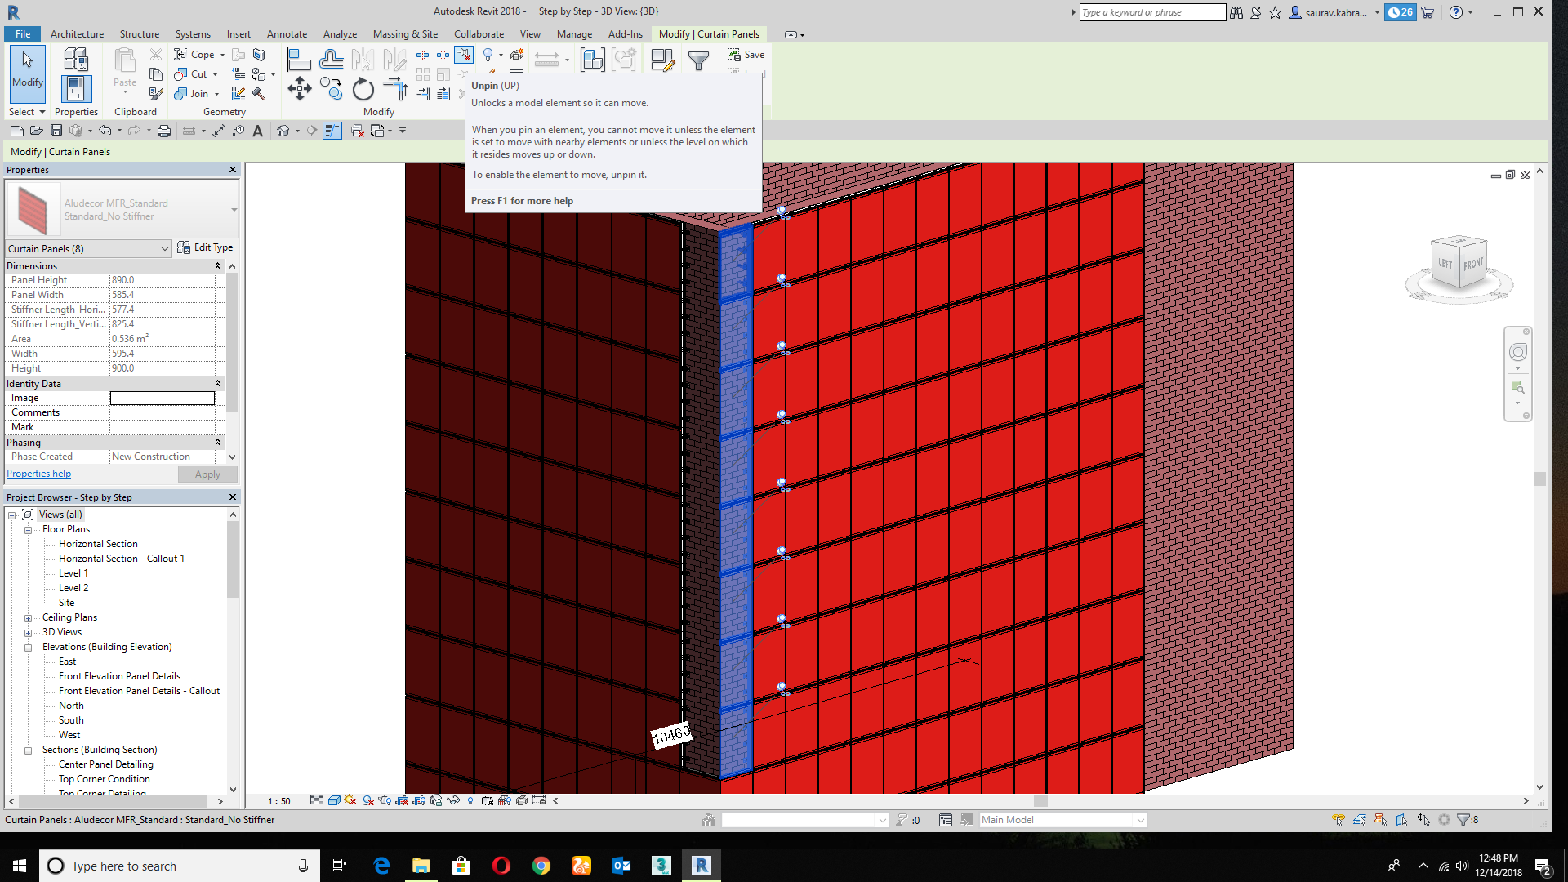
Go to the 3D view to and select the highlited panels to replace with the standard Corner Panel
How it will replace?
Select and unpin the highlighted panel and replace according to the orientation and don’t pin them again.

Step 7
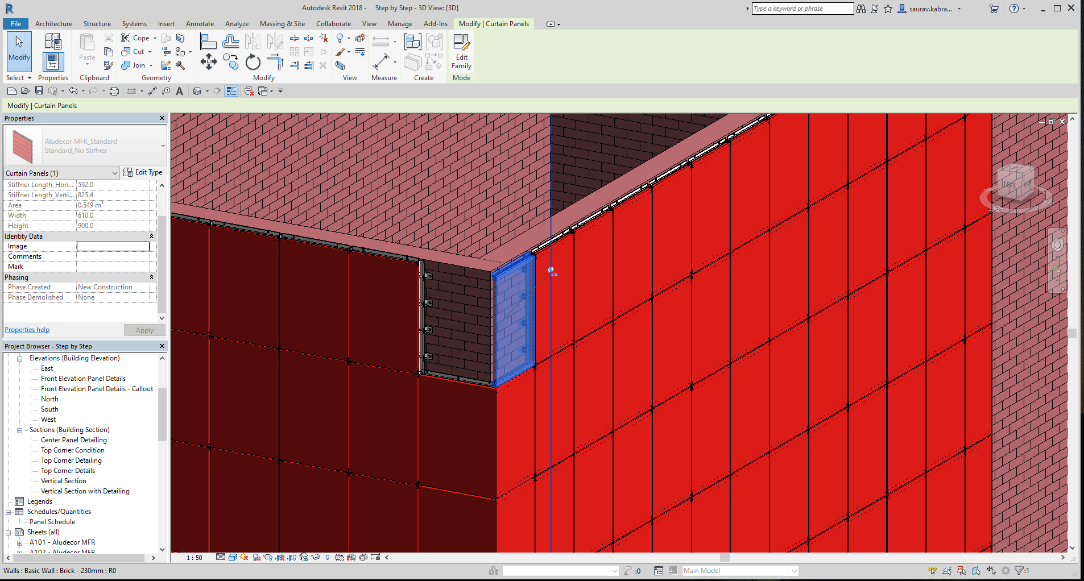
How to replace the corner top panel?
As similar to the Standard Corner Panel,select the top highligted panel and change it with the corner top panel.
Step 8
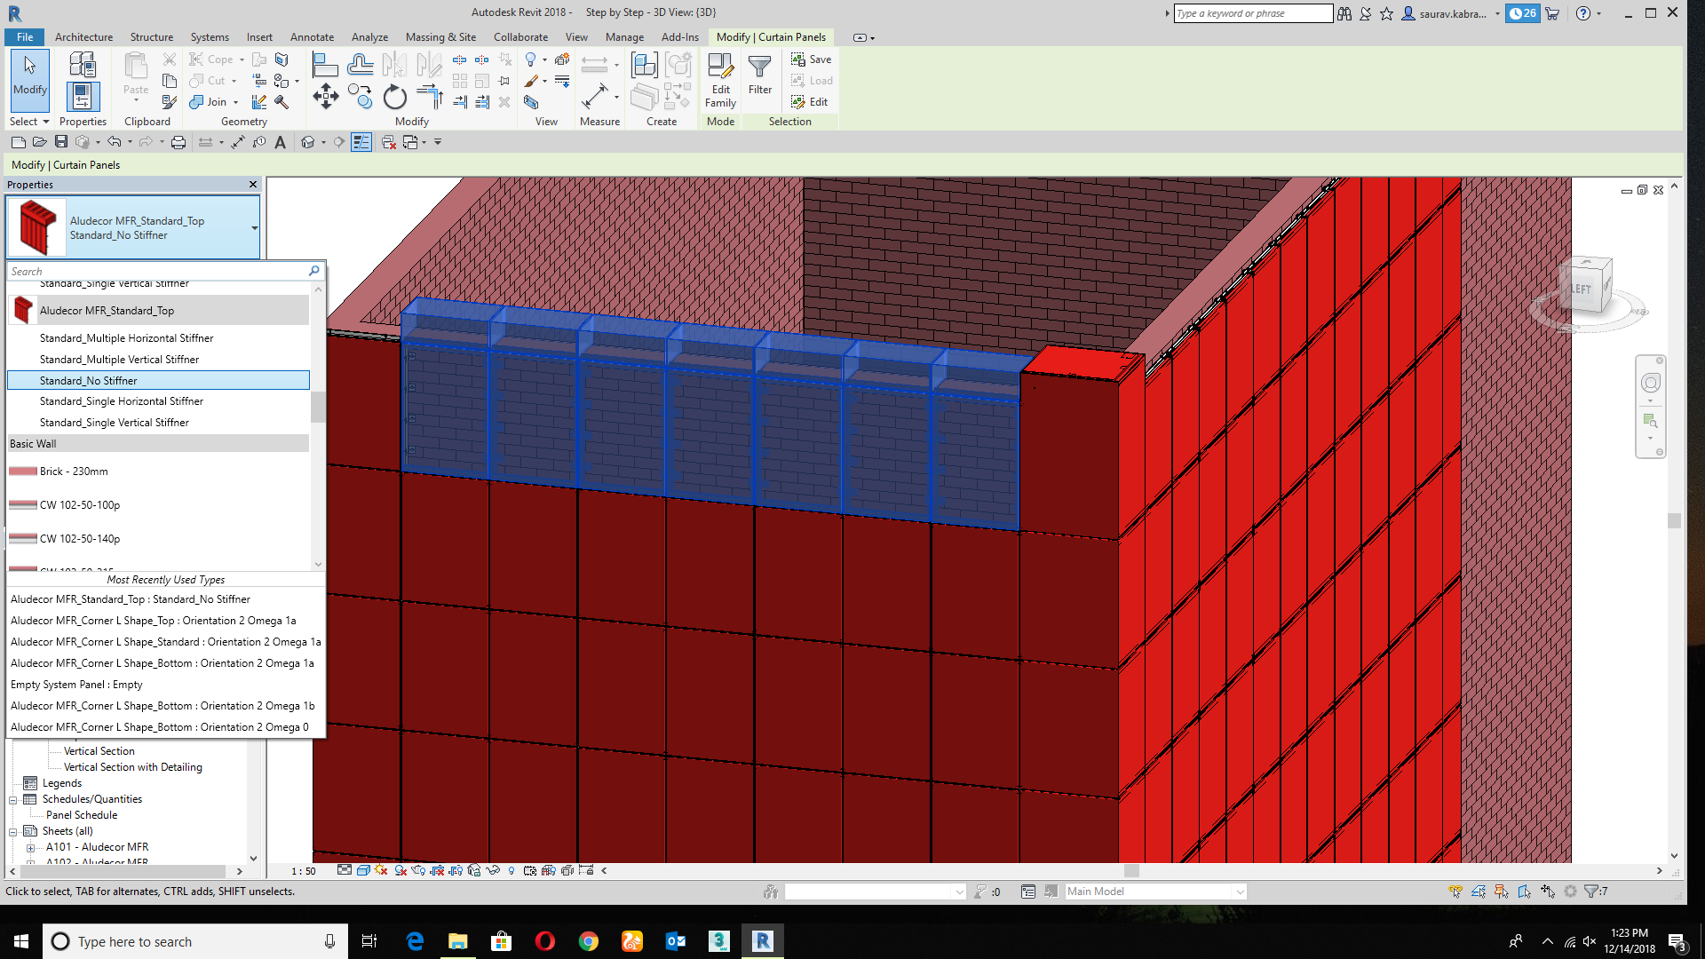
How to replace Center Top corner panel?
Select the center top panel and replace it with Center top Standard panel.
Step 9
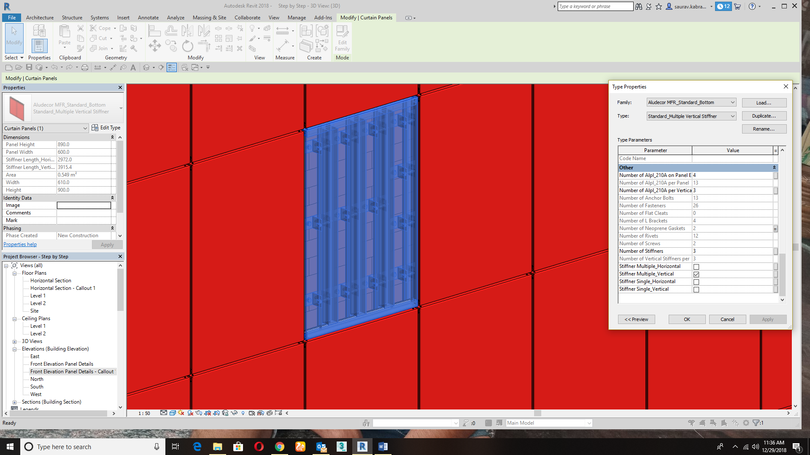
How to replace the standard panel to multiple panel stiffener?
Click on the specefic panel and change it in the property tab with Multiple Stifferner Panel.

Step 10
How to change the panel to Glass?
Click on the highligted panel and unpin the panel and change it with Glazed.
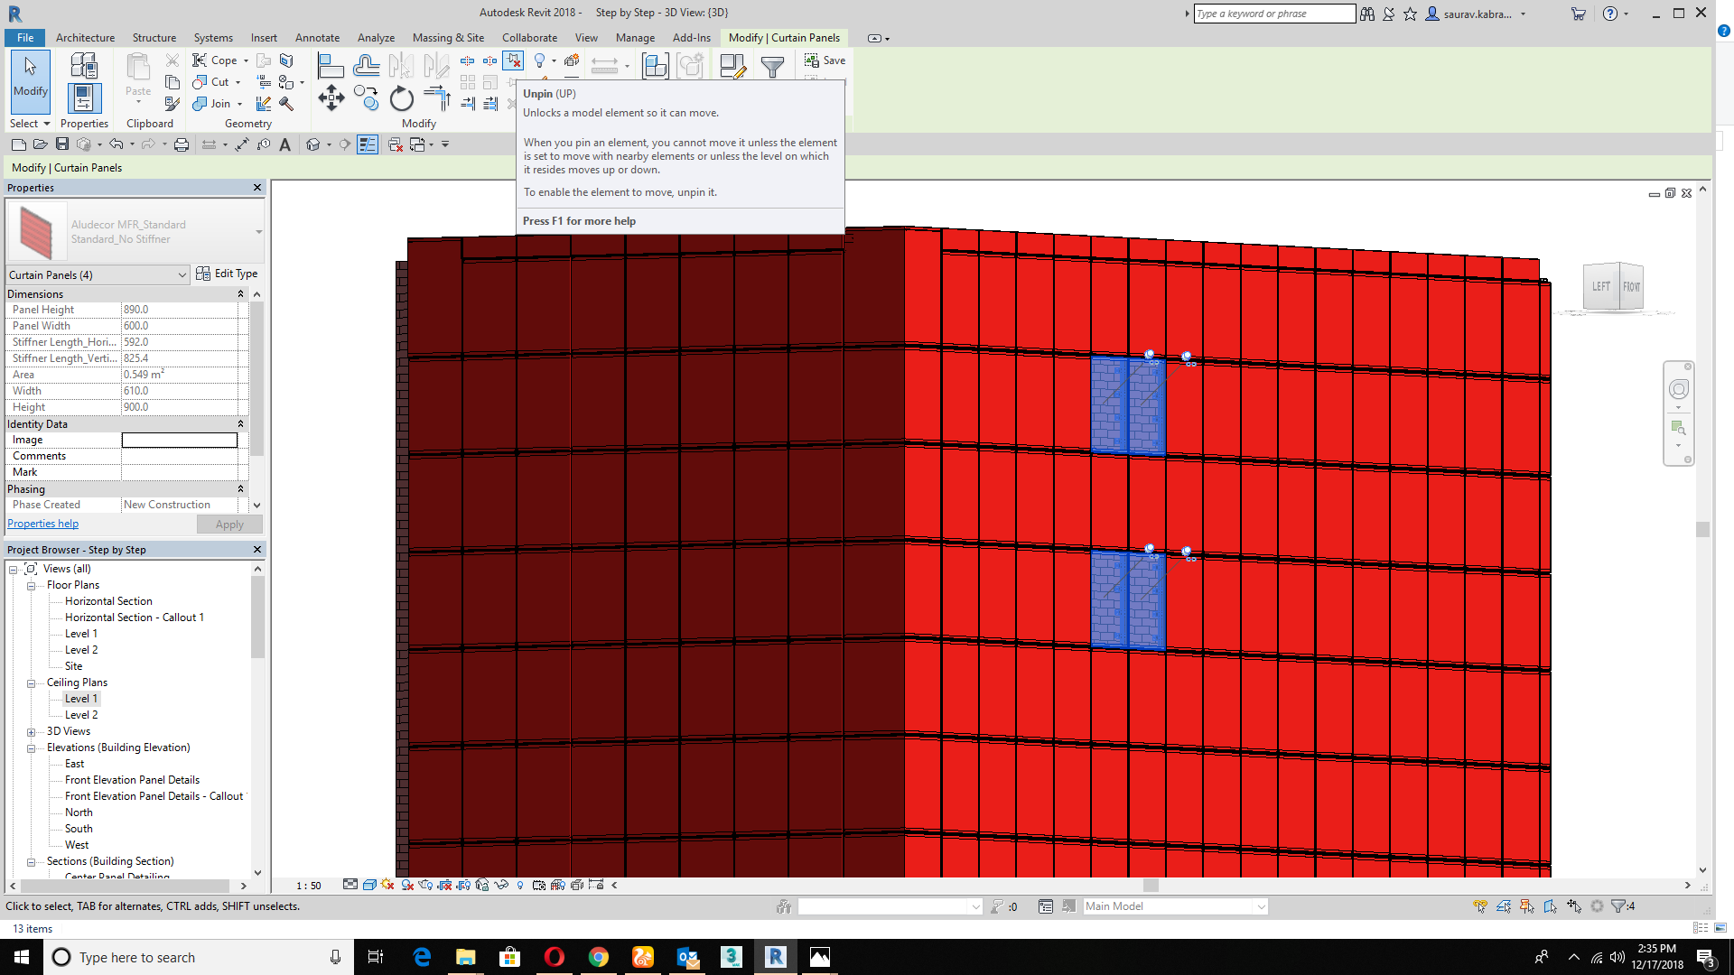
Step 11
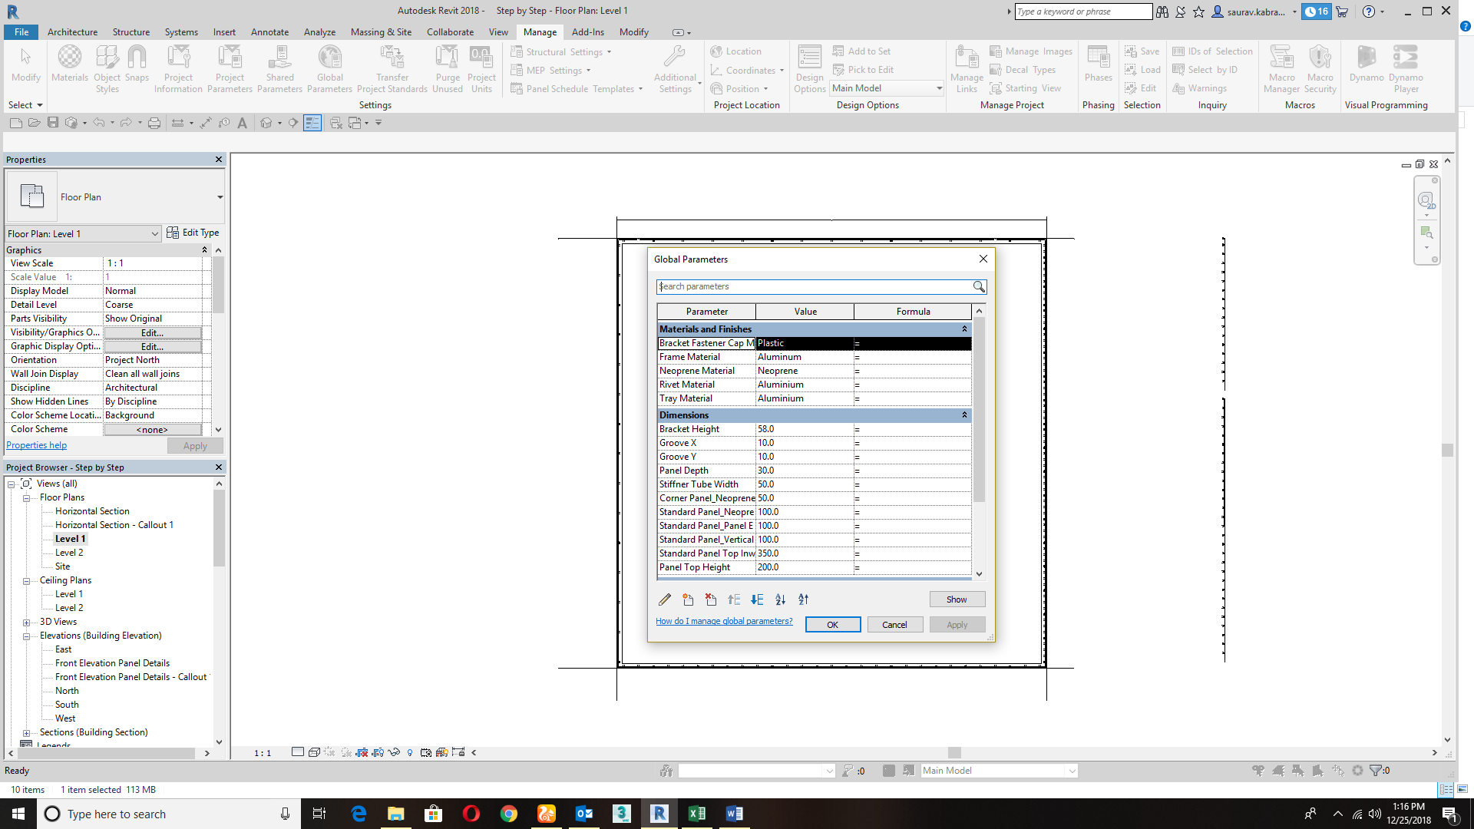
How Global Parameter Works?
Global Parameter are used globally in the project which helps to adjust the parameter with in the project.
Example:- If you want to change the Type X Groove size from 10mm to 12mm,then the size of groove will get changed with in the project.

Step 12
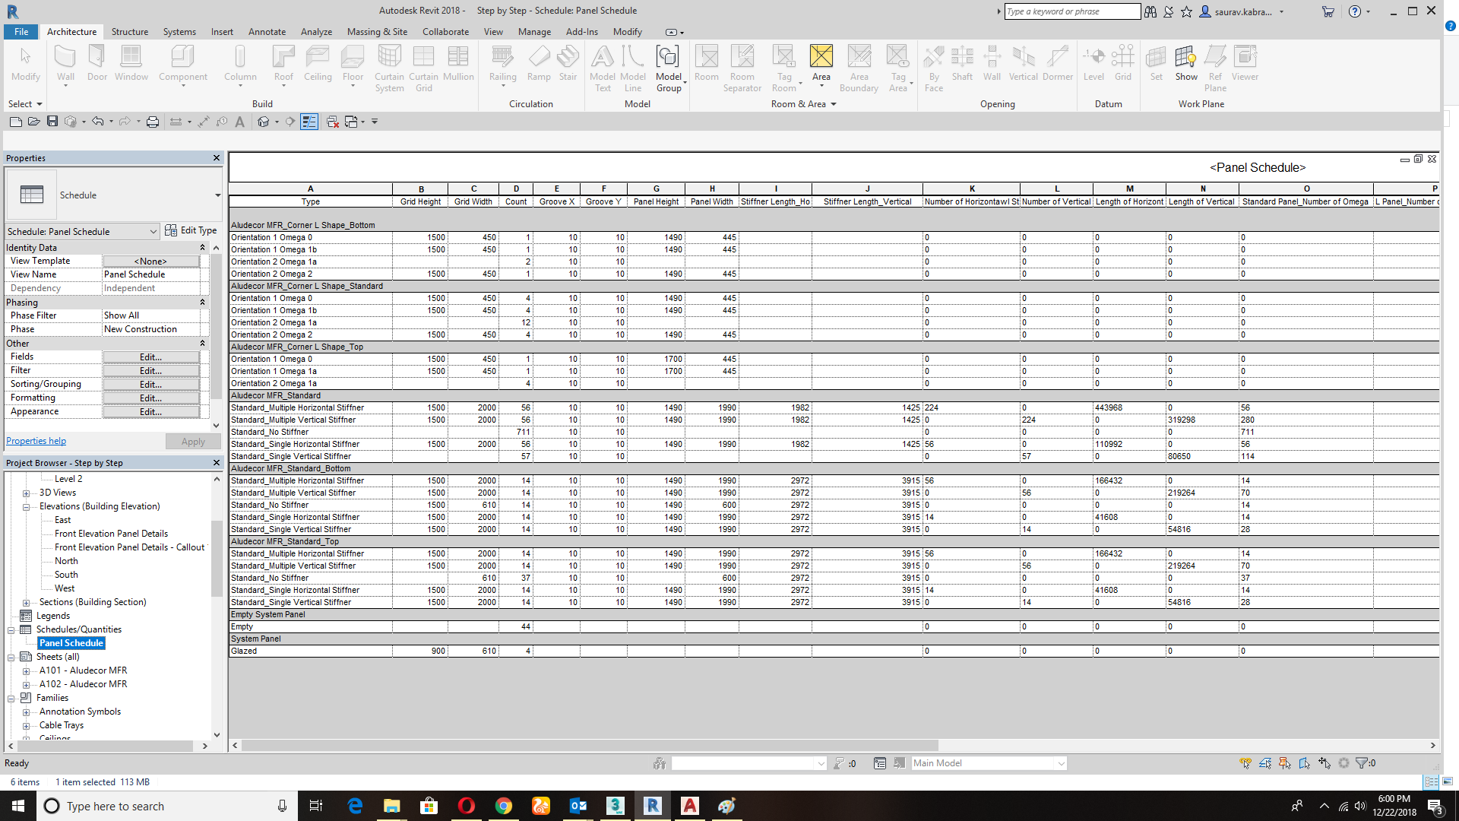
How to get the schedule of MFR System?
Go to the project browser tab and click on the schedule button and all of the information with size and quantity will display here.
Step 13
How to get the final quantity from the revit schedule?
Export the revit schedule file into .txt format.
Open the .txt file into Microsoft excel and you will get the full quantity.

